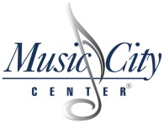

Exhibit E
Cost Criteria Form

Please provide a monthly fee to include all materials, labor, equipment and services necessary to perform Landscape Services stated in the RFP. All applicable fees should be included in the monthly fee.
Cost Data Worksheet for RFP 106-2018
Music City Center Exterior Landscaping Services
 |  | Year 1 | Year 2 | Year 3 | Year 4 | Year 5
 | Monthly Fee
 | Labor Hourly Rate
 | Hourly Minimum for Grass Cutting
 | Notes/Comments:
Also, provide a labor hourly rate for any additional tasks and hourly minimum rate for grass cutting.

