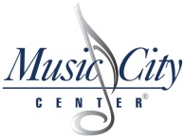
Exhibit E
Cost Criteria Form

The fee proposal should be presented in a table using the following format:

Cost Data Worksheet for RFP 103-2019
ELEVATOR/ESCALATOR MAINTENANCE SERVICES FOR MUSIC CITY CENTER
Proposer must enter for the following:
 |  | Year 1 | Year 2 | Year 3 | Year 4 | Year 5
 | Monthly Maintenance Fee
 | Also provide an hourly rate for each classification of technicians for work not covered in the maintenance agreement, the cost for required A 17.3 upgrades at the facility and any other fees that may be applicable during the duration of this contract.

