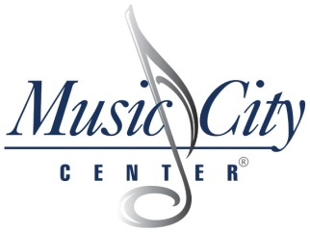
EXHIBIT E
Account Requirement Verification Form

This form must be completed and returned via email to
mccpurchasing@nashvillemcc.com
by October 8, 2020 by 3pm (CST)

RFP: 109-2020 – Food and Beverage Services for the Music City Center
COMPANY NAME:
NAME OF REPRESENTATIVE:
EMAIL:
PHONE:
In submitting this form, the signee acknowledges:

- The company has a current convention center account with at least Ten Million Dollars ($10,000,000) in gross food and beverage sales annually within at least one convention facility that is similar in size to the Music City Center,

- The company can adhere to the RFP timeline,

- The Authority is also evaluating the merits of self-operating all food and beverage operations and may choose not to make any section pursuant to this RFP, and

- The company will be able to mobilize and commence operations by May 20, 2021.

Print Name | Date
Authorized Signature | Date

