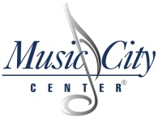
Exhibit D

List of Proposed Diversified Business Enterprise

Proposer Name: ______________________________________

Notice: DBE businesses listed must be registered with Metropolitan Government of Nashville and Davidson County (Metro) and small business status must be approved by the Metropolitan Government or DBE Certification prior to proposal submission.

 | DBE Business Name | Business Address, Phone Number, and email address | Work to be Performed by this  DBE Business | Minimum of total dollars to be spent with this DBE Business | Business Classification Type

TOTAL _________

Submission of a proposal shall constitute Proposer’s representation that neither Proposer nor an officer, agent or employee of Proposer, or the spouse, parent or child of an officer, agent or employee of Proposer, is involved in the ownership, operation or management of any sub-contractor claiming status as a DBE business for purposes of this Proposal and Contract.

Signature: Date:

