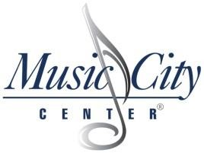
EXHIBIT C GOOD FAITH EFFORT VERIFICATION FORM

Please complete this form to provide Convention Center Authority with information regarding your outreach efforts. Please include information appropriately regarding those certified MWBEs that you contacted, who contacted you and those with whom you have decided to work on this project. Please add additional copies of this sheet as necessary so that you may list ALL MWBEs with whom you’ve had contact. Please contact Director of Purchasing/DBE 615-401-1445.

Project Name RFP Number___________________

As part of our regular and customary good faith efforts to include MWBE subcontractors, suppliers and joint ventures, ________________________ has contacted or was contacted by the following certified MWBEs related to our bid/proposal.

Business Name & Contact | Phone No | MBE/WBE  Certificate Type | Date of Contact | Method of Contact | Who Initiated Contact? | If Bid Submitted, Amount of Bid* | Offer  Accepted or Declined | Reason(s) for Declining
*STATEMENT OF BID/PRICE QUOTATION

Name____________________________________ Title_________________________ Date_______________________

