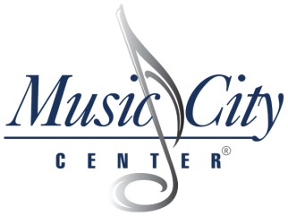
EXHIBIT C
Official Bid (OB)

Instructions:
- Bids should be submitted by the time and date specified above.
- The vendor should provide the information below.

MAILING ADDRESS: | HAND DELIVER ADDRESS:
Music City Center  700 Korean Veterans Blvd  Nashville, TN 37203 | Music City Center  600 Korean Veterans Blvd  Nashville, TN 37203

VENDOR INFORMATION
Company Name:
Name  (type or print): |  | Title:
Address:
City: |  | State: |  |  | ZIP Code:
Telephone Number: |  | Fax Number:
E-Mail Address:

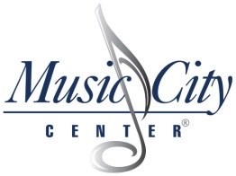

EXHIBIT C (cont.)
Official Bid Price Sheet
Description Of Service | Lump Sum Fee
Remove existing florescent lamp. Purchase and Installation of all required LEDlescent/ECO LED Lamps to replace existing lamps. Ballast to remain in fixture  There are approximately 2,155 fixtures which include approximately 5,289 lamps. | $

NAME OF BIDDER:
EMAIL:
PHONE:
In submitting this bid, proposers represent: A) that the proposers has examined and carefully studied the Bidding Documents; and B) that all components and parts are accounted for and included to complete the product and specification requirements.
Print Name | Date
Authorized Signature | Date

